ΕΛΛΗΝΙΚΗ ΔΗΜΟΚΡΑΤΙΑ
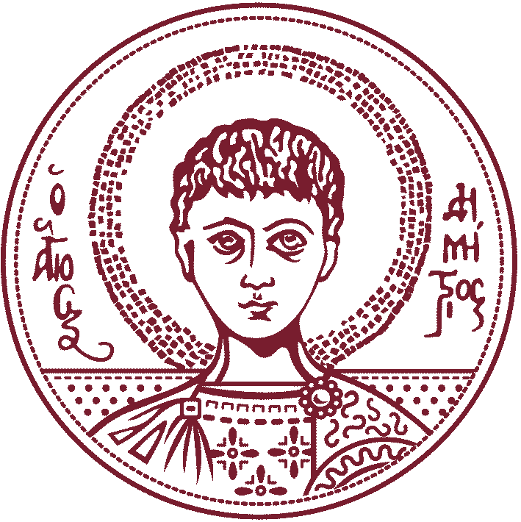

Aristotle University of Thessaloniki

Lecture Invitation

The Signal Processing and Biomedical Technology Unit of the Electrical and Computer Engineering Department, AUTH and the Student IEEE Chapter of AUTH, in collaboration with the School of Music Studies, AUTH, invite you to the lecture entitled:

“Concept invention in melodic harmonization through conceptual blending”

on Tuesday, May 13th 2014 at 18:30 at the Building Δ’ Conference room of the AUTH Polytechnical School.

Lecturers: Emilios Cambouropoulos, Maximos Kaliakatsos-Papakostas
School of Music Studies, AUTH.

The lecture is in the context of the European Research Program “COINVENT (Concept Invention Theory) (FP7-ICT-2013-10, grant agreement n° 611553: “COINVENT” Project (http://www.iiia. csic.es/coinvent/)). Emilios Cambouropoulos is an Assistant Professor and Principal Investigator of the project for the School of Music Studies, AUTH, while Maximos Kaliakatsos-Papakostas is a post doctoral research fellow at the same project and department.

Lecture Content
Electronic computers are carrying out more tasks in contemporary life and under this concern, a distinguishable research direction regards the ``creativity’’ potential of computers’ functionality. Concept Invention Theory (COINVENT) is a European Research Project that discusses computer creativity by examining computational methodologies for concept invention, which are based on Goguen’s Unified Concept Theory as well as from other ideas from cognitive and social theories of conceptual blending.
Among the application fields of the aforementioned methodologies is melodic harmonization, which discusses the generation of harmonic content that is compatible with a given melody. Specifically, within the COINVENT framework, the blending of harmonic concepts from different music idioms is examined, which results in the creation of novel concepts that lead to ``blended’’ harmonizations of given melodies. The development of such methodologies around the melodic harmonization task raises many challenges, from the global representation of harmonic concepts among different idioms to the combination of statistical learning and logical reasoning on ontologies.
The lecturers will provide a brief description of the aims of COINVENT and a more detailed description of the utilized computational models for melodic harmonization. Additionally, the challenges that have been tackled and the ones that remain to be tackled after the first semester of research activity will be analyzed.

~~~~~~~~~~~~~~~~~~~~~~~~~~~~~~~~~~~~~~~~~~~~~~~~~~~~~~~~~~~~~~~~~~~~~~~~~~~~~~~~~
For more info please visit: http://www.iiia. csic.es/coinvent/

Event Information:
Date: Tuesday, May 13th 2014 at 18:30
Room: Building Δ’ Conference room of the AUTH Polytechnical School.
Contact Information:
Emilios Cambouropoulos, School of Music Studies, AUTH, Principal Investigator
(emilios@mus.auth.gr)
Maximos Kaliakatsos-Papakostas, School of Music Studies, AUTH, post doc research fellow (maximoskalpap@gmail.com)
Leontios J. Hadjileontiadis, Department of Electrical and Computer Engineering, AUTH(leontios@auth.gr)
Organization:
Processing and Biomedical Technology Unit
Student IEEE Chapter of AUTH
School of Music Studies, AUTH
COINVENT Project

